Task 10

Creating Executable Programs
One of the things that Visual Basic programs all require to run is the environment. Unlike C or Pascal code Visual Basic is interpreted line by line from within the Visual Basic Environment. If you wish to use the code of C it should be compiled and turned in into executable instructions. If you wish to use a Visual Basic Code outside the Visual Basic environment, it is also necessary to compile the program into executable instructions. In order to convert Visual Basic text into instruction that can be used outside the environment. There are two areas in the project properties which effect how the code will be compiled into executable instructions. They are under the Make and Compile tabs

Make Setting

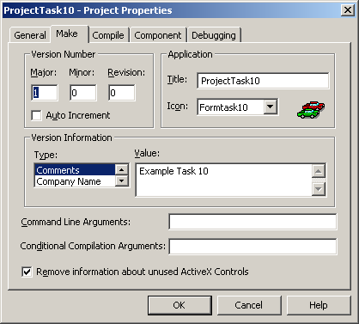

The Make tab controls items like the Title of the Application, the version number copyright messages and so forth. In order to see the effect of these look at the version tab of property window of the created executable program. Once the program has been compiled and turned into a standalone application it is useful to have information about the program. Many times the comments may indicate the use to which the program can be placed. The Company can be used to indicate the software house that developed the program. All this information once completed will be available as part of the programs properties. These are made visible by selecting properties on the on the right mouse button menu when on the program file.

Program Properties

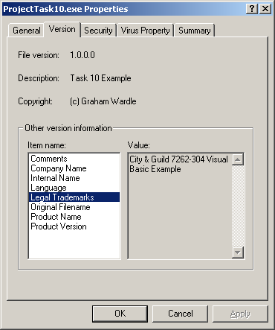

The lists of properties are often useful for determining the source of the program, and also the software release. Compare the property values for other executable file from various software suppliers to see for what the different fields are used. Set the program properties for your program to reflect its source and use to match the schemes used by other executable programs.

Compile Settings
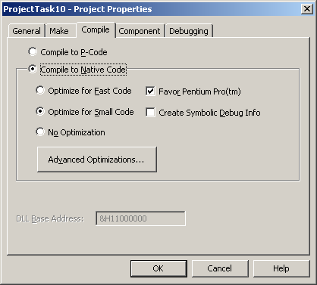

The properties of the project can be set for different compilation settings depending on what type of program is required. For example if you should wish to use only Pentium Pro for running your program it is possible to favour such code by selecting that as one of the options. If the program is compiled for P-code the program may only be used on systems with the Visual Basic environment installed. Other options include making the code as fast as possible or as small as possible.

Making the executable
The visual basic project can be translated into executable file this file will have files that it will be dependant upon in order to work on another computer. This dependency can be determined by a number of tools that take the project file and create a deployable executable.
If there is no requirement for the program to run on another machine then turning the project into an executable only requires the following steps to be actioned.
- Select the ‘File’ Menu.
- Select ‘Make…’ Sub menu item
- Enter a file name for the executable in the dialog that appears.
- If the same name is used select yes or no to replacing the old version.
- If there are no error is your code an executable will be created.
- If there are errors it may be useful to run the program with the full compile option. That is on the ‘Run’ Menu under the sub menu of ‘Start with Full Compile’ or Ctrl + F5.

Screen shot of Make Project File Dialog
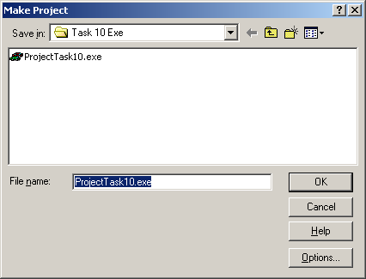

Screen shot of Compile error
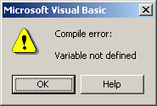

Exercise
For a previous program set the make and compile properties and compile the program. Test the program properties and the program functionality. Also try getting the program to fail and see what happens on failure of the program. If you have difficultly getting a failure add a deliberate fault such as divide by zero.

